# GEN AI PROJECT PHASE 2 - Execution & Demonstration

Project Title: Chatbot Assistant using Generative AI

## Technologies Used

• Python  
• HuggingFace Transformers  
• GPT-2  
• Google Colab  
• Streamlit (GUI version)

## Colab Code Implementation

Step 1: Install Required Libraries

```python  
!pip install transformers  
```

Step 2: Import Required Libraries

from transformers import pipeline, set_seed

Step 3: Load Model

chatbot = pipeline('text-generation', model='gpt2')  
set_seed(42)

Step 4: Chat Function

def chatbot_response(prompt):  
 responses = chatbot(prompt, max_length=100, num_return_sequences=1)  
 return responses[0]['generated_text']

Step 5: User Input Loop

while True:  
 user_input = input("You: ")  
 if user_input.lower() in ['exit', 'quit']:  
 print("Chatbot: Goodbye!")  
 break  
 print("Chatbot:", chatbot_response(user_input))

## Output

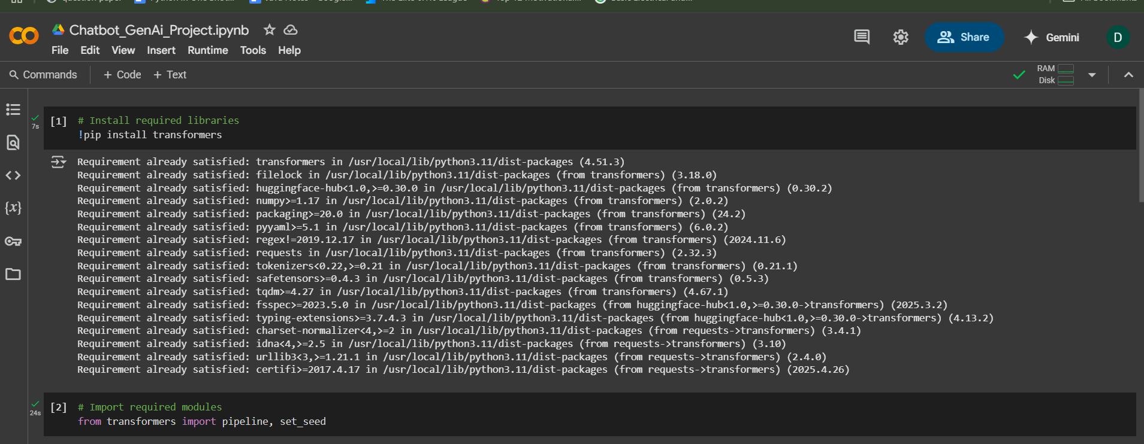

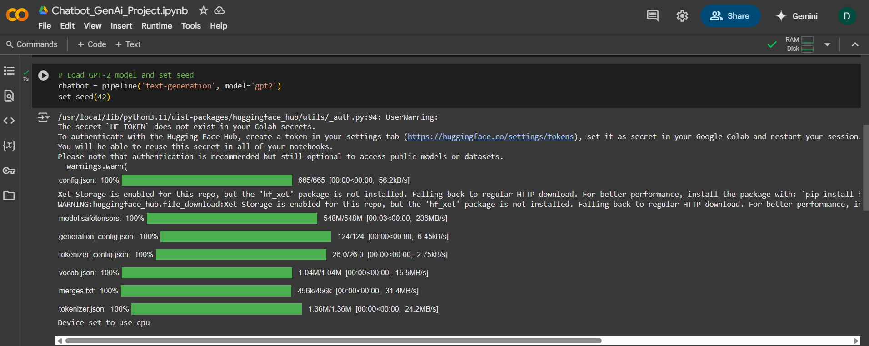

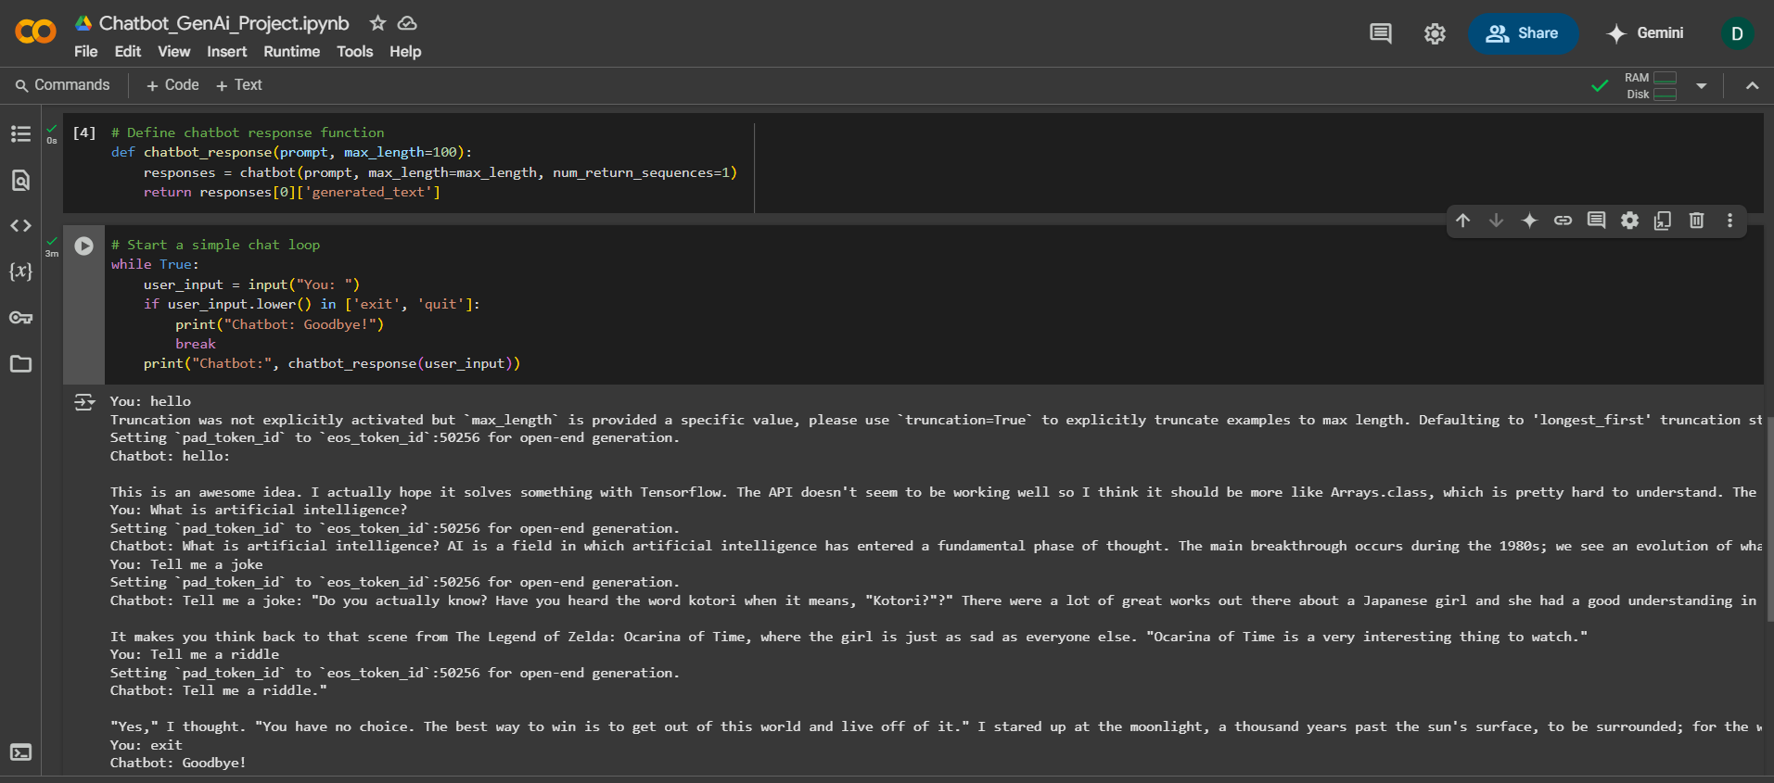

## Streamlit GUI Version

```bash  
pip install streamlit transformers  
```

```python  
import streamlit as st  
from transformers import pipeline, set_seed  
  
st.title("Chatbot Assistant using Gen AI")  
user_input = st.text_input("You:")  
if user_input:  
 generator = pipeline('text-generation', model='gpt2')  
 set_seed(42)  
 response = generator(user_input, max_length=100, num_return_sequences=1)  
 st.write("Chatbot:", response[0]['generated_text'])  
```